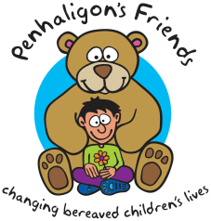
Penhaligon’s Friends
Level 1 Childhood Loss and Grief Training
18th,25th Sept & 2nd Oct 2024 - Fee: £165

Full Name

Organisation

Address

Phone Number Mobile

Email Address

Invoice Address
(If different)

PO Number
(If applicable)

Any Support
or Assistance
Required?

Payment Options:
BACS: Sort Code: 30-98-76, Acc No:00322598, Lloyds TSB. Please quote delegate name as reference.
Cheque: Payable to Penhaligon’s Friends and sent to the address below.
Booking conditions: A refund will be given for cancellations less a £30 admin fee. No refunds will be given for cancellations less than 2 weeks before the event. Places are transferrable at the discretion of Penhaligon’s Friends.
We would love to keep in touch to let you know what we’re up to but we will never share your details with third parties. If you would rather not hear from us please tick:

