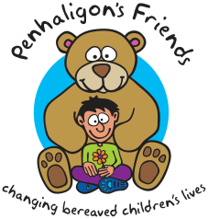
Penhaligon’s Friends
Level 1 Childhood Loss and Grief Training
18th Jan, 25th Jan & 1st Feb 2022 - Fee: £165

Full Name

Organisation

Address

Phone Number Mobile

Email Address

Invoice Address
(If different)

PO Number
(If applicable)
Please note: We can cater for vegetarians but for more complex dietary requirements please call or email the office to discuss.
Dietary
Requirements

Other Needs

Payment Options:
BACS: Sort Code: 30-98-76, Acc No:00322598, Lloyds TSB. Please quote delegate name as reference.
Cheque: Payable to Penhaligon’s Friends and sent to the address below.
Card Payment: Please call the office to pay by card, a £5 fee will be charged on card payments.
Booking conditions: A refund will be given for cancellations less a £30 admin fee. No refunds will be given for cancellations less than 2 weeks before the event. Places are transferrable at the discretion of Penhaligon’s Friends.
We would love to keep in touch to let you know what we’re up to but we will never share your details with third parties. If you would rather not hear from us please tick:

